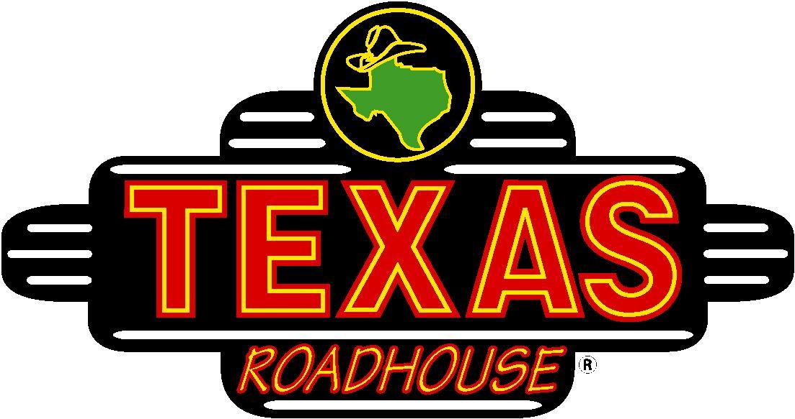

Bread and Gift Card Fundraiser!

Forget about the candy, pies, and wrapping paper, and let’s raise money with something everybody wants…Legendary Food! This is the best fundraiser with the most legendary donation return for our organization!

All order forms and money are due by Friday, September 24th.

As for the Bread/Butter…

Frozen Bread = $5.00 Pint (8ounce cup) = $2.00
YOUR REWARD = each student account will be credited $1.00 per dozen and $0.50 per pint.

As for the Gift Card...
They can be done in any denomination from $5 to $100. Gift Cards have a 5% donation return to your student account.

Selling dates: Orders must be turned in by Friday, Sept. 24th.
Orders must be picked up on Wednesday, Nov. 10th.

How it works: The bread comes frozen with baking instructions, which makes them perfect for any Holiday or family get together. Since the bread comes frozen all orders must be picked up on November 10th. We do not have freezer space to hold any orders.. Please note. all checks should be made out to the New Palestine Band.

If you have any additional questions, please reach out to NPBBfundraising@gmail.com.

Happy Fundraising!

